**Cabildo, Adan L. | BSCS-SS212**

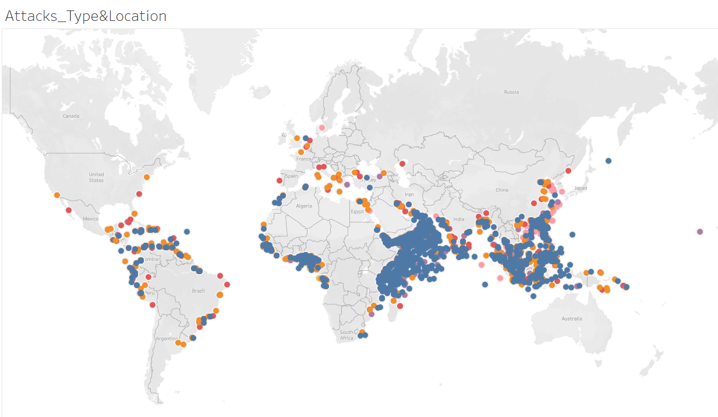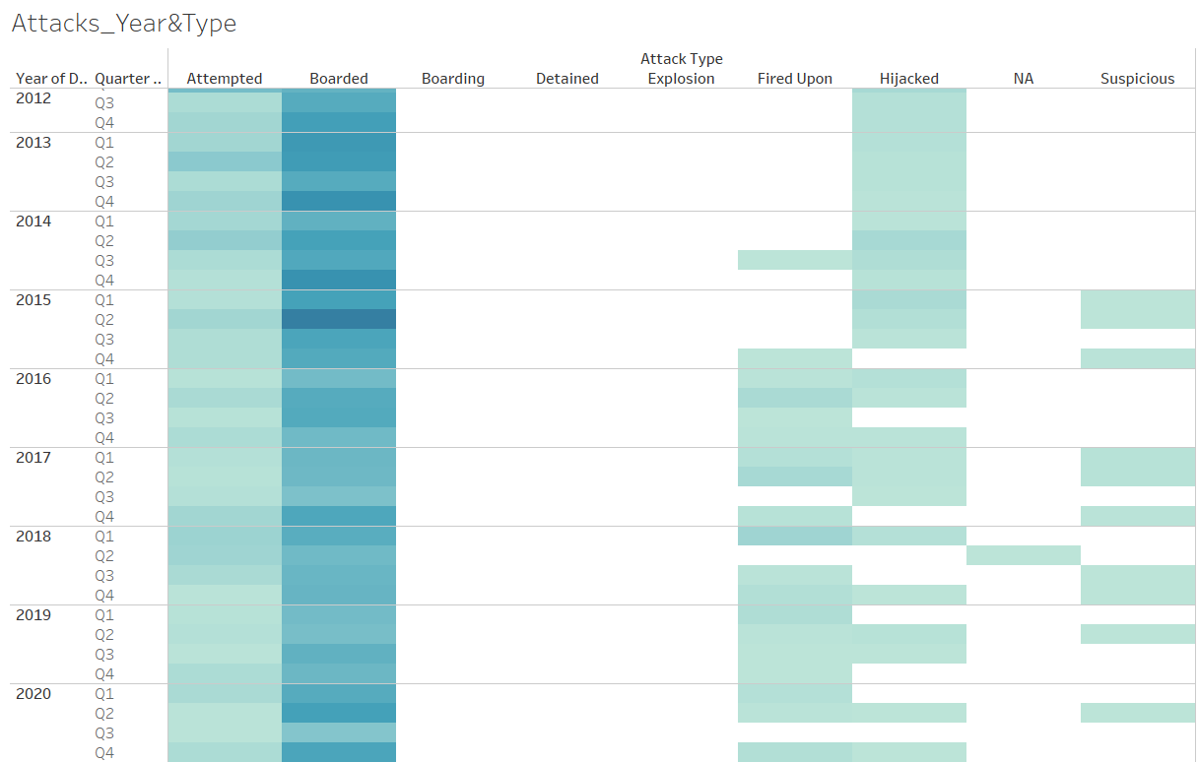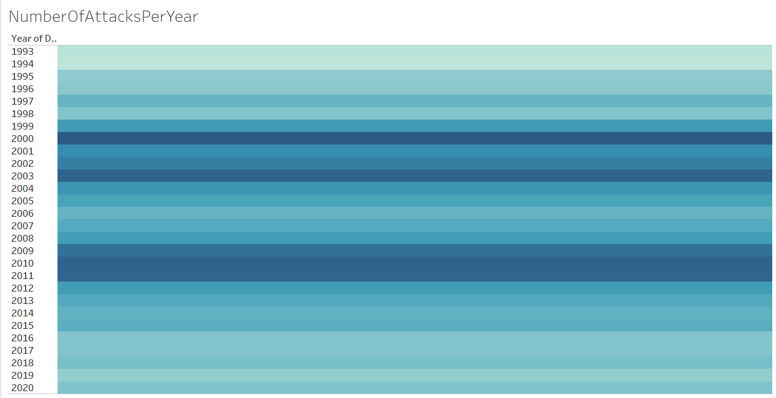

**Time and Geolocation of Pirate Attacks for Safer Cruising and Ship Logistics**

1. **What problem/question(s) would you solve with analytics? What decision is being improved?**
   1. What choices are being faced that require a decision?
   2. What's the organizational context of the decision?

Questions such as:

* What is the frequency of Pirate Attacks in a particular location?
* Which months are safer for cruise ships and logistics to travel through a particular location?
* Which ships is more likely to be attacked by pirates?

1. **Who benefits from the problem being solved?**

* Civilians, Cruisers, and Logistics Companies

1. **Who is deciding?**
   1. Who are the stakeholders, influencers, and decision makers?

Decision makers such as:

* Cruiser companies
* Logistic companies
* Ship captains

1. **What’s the impact of solving the problem? What is the value of an improved decision?**
   1. What does improvement mean?
   2. How should decision improvement be measured? Metrics usually go beyond accuracy.
   3. How much should we invest in improving the decision? Consider the costs of implementing an analytics solution versus the likely benefits.

Solving the problem will impact the following:

* Keep the annual count of pirate attacks below 200.
* Reduce civilian, employee, and security personnel casualties.
* Minimize financial losses resulting from pirate attacks.
* Stakeholders will gain larger profit from increased safety of cruise and logistic ships with increased safety of human lives while investing smaller costs for gathering data for such analysis.

1. **Where will you get your data?**
   1. Kaggle link: <https://www.kaggle.com/datasets/n0n5ense/global-maritime-pirate-attacks-19932020>

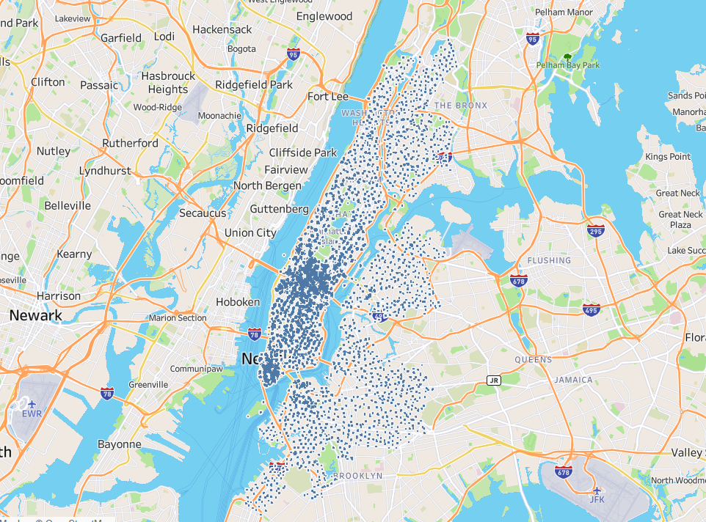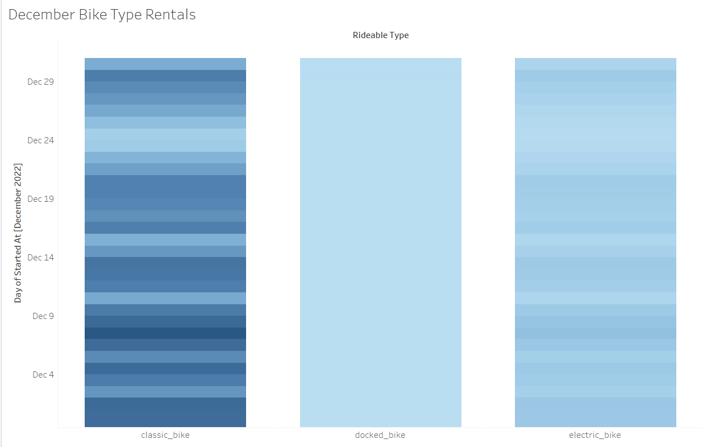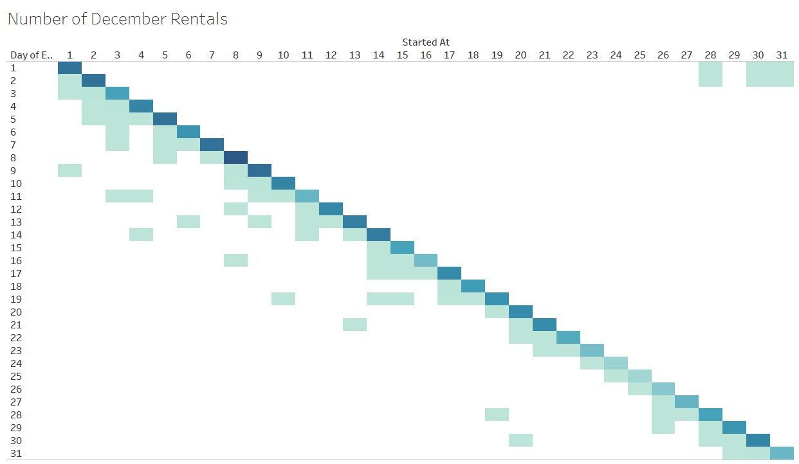

**Analyzation of December Citi Bicycle Rentals in NYC for Potential Promos and Membership Types**

1. **What problem/question(s) would you solve with analytics? What decision is being improved?**
   1. What choices are being faced that require a decision?
   2. What's the organizational context of the decision?

Questions such as:

* Do we need to increase the number of bicycles? If so, what stations?
* Do we need to add another membership type for customers who rent bicycles for a longer period?
* Is it recommended to add a Christmas promo to increase rentals during Christmas?
* Do we need to increase prices in stations that have a higher number of rentals?

1. **Who benefits from the problem being solved?**

* Citi Bicycle Company
* Customers
* Environment

1. **Who is deciding?**
   1. Who are the stakeholders, influencers, and decision makers?

Decision makers such as:

* Citi Bicycle Company
  + Marketing
  + Production

1. **What’s the impact of solving the problem? What is the value of an improved decision?**
   1. What does improvement mean?
   2. How should decision improvement be measured? Metrics usually go beyond accuracy.
   3. How much should we invest in improving the decision? Consider the costs of implementing an analytics solution versus the likely benefits.

Solving the problem will impact the following:

* Increase the number of rentals to 2 million in the following month.
* This analyzation will return a larger benefit to the company such as improved marketing with increased number of members riding the Citi bicycles around New York City while investing in small tweaks with promos and additional membership types.

1. **Where will you get your data?**
   1. Kaggle link: <https://www.kaggle.com/datasets/leonczarlinski/citi-bike-nyc>